PIZZANOMICON Recipe (eat it before it eats your soul)

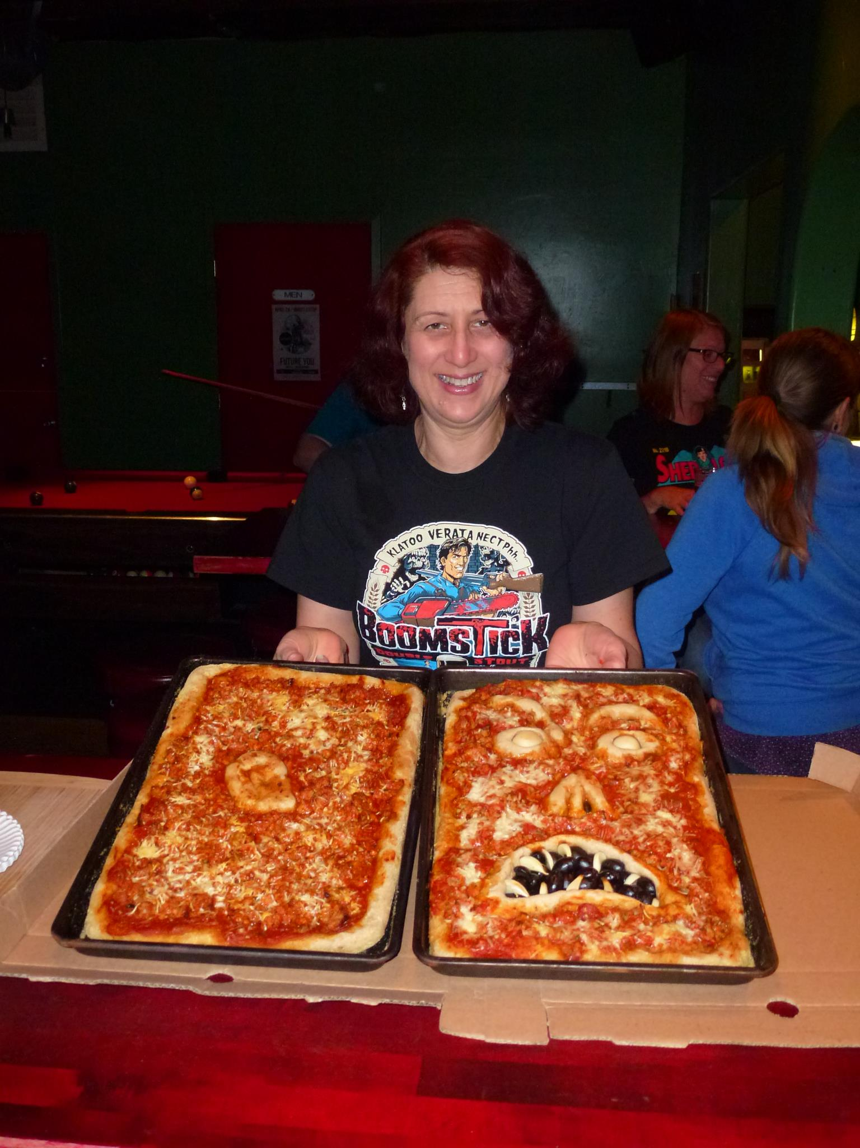

Crust:
1 Packet active dry yeast
1 T Sugar
1 Cup warm water (You can replace the water with a cup of warm beer if you want to sacrifice some San Diego craft beer to the Deadites)
1 tsp salt
2 Cups flour (you can mix white and whole wheat)
Directions:
1) Combine yeast, sugar, and warm water in a large bowl. Allow to sit until the yeast forms a layer of foam on top of the water-about ten minutes.
2) Mix in salt, and flour- stir with a spoon until it forms a uniform ball. Add more flour if needed, and knead by hand on a smooth surface, or knead with dough hook in mixer until well mixed.
3) Place dough in an oiled bowl and cover with a damp cloth. Let rise for an hour.
4) Punch your dough down and briefly knead on a smooth surface. Preheat oven to 400 degrees Fahrenheit.
5) Roll out dough to fit baking sheet (about a quarter of an inch thick). Reserve some pieces of dough to make mouth, nose, eyes, and ear (for back of “book”). Use black olives for the evil mouth, whole garlic cloves for eyes, and sliced garlic for teeth.
6) Add your sauce, cheese, and toppings and bake for 12-15 minutes. Crumbled sausage gives it a nice rotting flesh texture and small pepperoni can look like sores.
Sauce:
You can make whatever recipe you use for your own spaghetti sauce and use to top pizza or for quick version try Barilla or Newman’s Own jars of your favorite tomato sauce. You can enhance sauce with added chopped garlic, basil, oregano, chopped bell peppers, red wine, and/or grated or chopped onion. Simmer for at least 30 mins.
For cheese, fresh mozzarella is best with a little grated Parmesan on top. Provolone also works. I am Italian so I will not discuss vegan pizza or adding pineapple.

Suggestion for using black olives and sliced garlic for mouth.

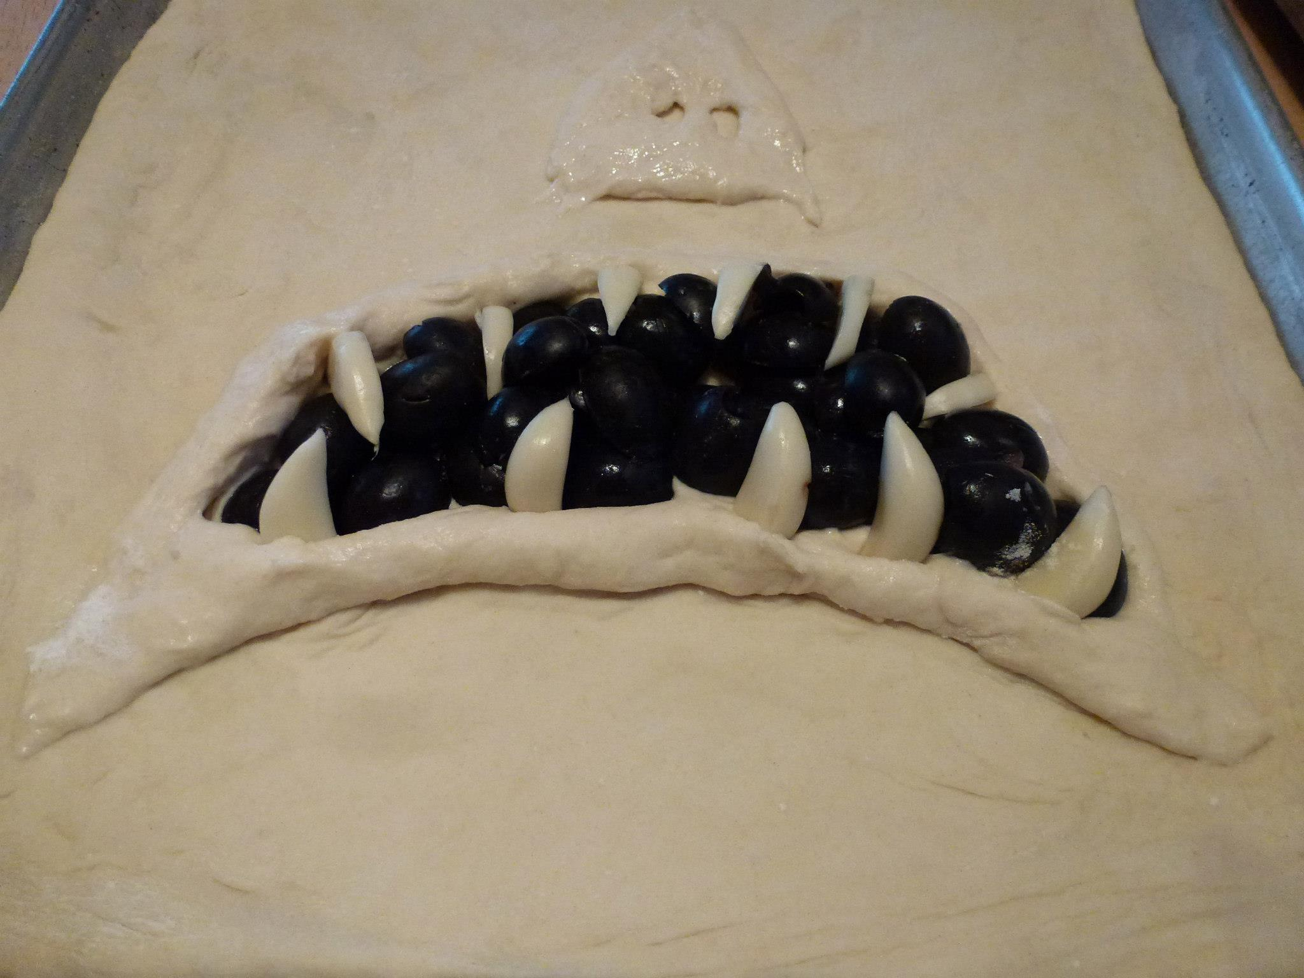

Garlic clove eye.

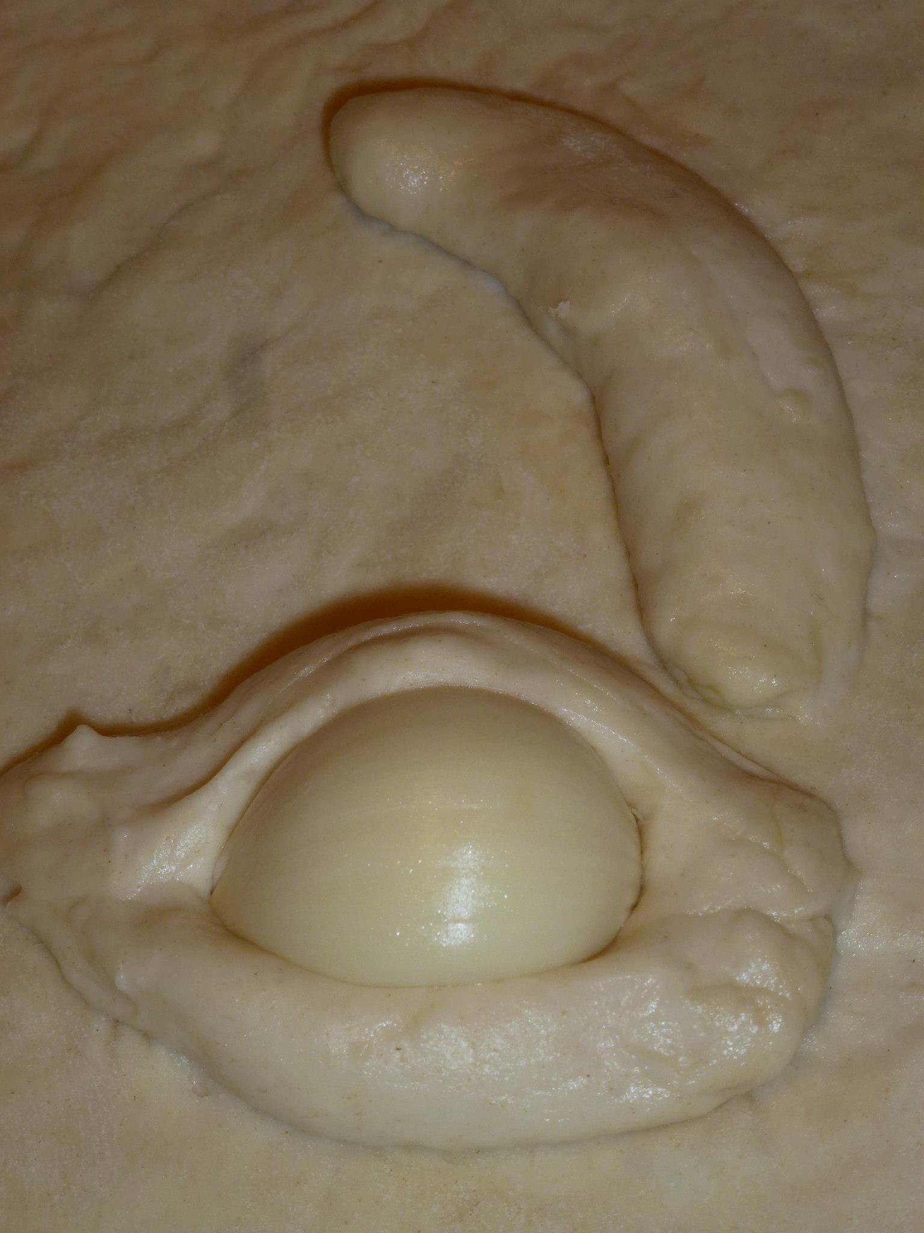

Front and back of the Pizzanomicon book ready to go in oven.

